BEST Project Post Go-Live Support Process and Procedures

(Do not edit this document)

Document Author(s): | Mark Kithcart  (BEST)  Chris Chen (CGI) | Document Reviewers: | Pat Smith  Tracy Minor Nkeiruka Benson Renee Mills Sean Lewis  Paul Landry Tony Lucich  Help Desk Core Team
Version: | DRAFT | Approved Date:
Document Number: | v2.3 |  | 03/01/2019
Initial Date: | 02/08/2018
Last Revision: | 04/12/2019
Revision History: |  | Revision Description:
 | 02/08/2018 | - Initial Draft
 | 03/16/2018 | - Edits and Issuance to Broader Team for feedback
 | 04/23/2018 | - Feedback from Draft v04232018 incorporated
 | 06/01/2018 | - Updates for FIN SME Resources
 | 09/21/2018 | - Updates for FIN SME Resources
 | 01/10 – 02/28/19 | - Updates for BUD/FIN SME Resources; Service  Hours Update
v.2.3.1 | 03/01/2019 | - BOMGAR Process Flow
v.2.3.2 | 04/01-04/30/19 | - FIN Go Live Updates
v.2.3.2 | 06/01-06/30/19 | - FIN Go Live Updates
v.2.3.4 | 01/01 – 10/09/20 | - HCM Go Live Updates

Table of Contents

Overview, Purpose, and Scope 5
Overview 5
Purpose 5
Scope 5
Contact Information and Available Service Hours 6
BEST Advantage System Availability & Announcements – BEST Portal and Remote Access URL 6
BEST Advantage System Availability 6
Post Go-Live Support Personnel Organization 6
Performance Budget (BUD) 6
Financials (FIN) System 7
Human Capital Management (HCM) 8
Post Go-Live Support Process and Procedures 10
Help Desk High Level Process 10
Purpose 10
Description 10
BOMGAR Detailed Process – Continuance 12
Description 12
Issue Resolution Detail Process 14
Purpose 14
Description 14
New User Mandatory Training Process and Security Access Assignment 16
New User Mandatory Training Process 16
Purpose 16
Description 17
Security Access Assignment Process 18
Purpose 18
Description 18
Functionality BUG Solution Process 20
Purpose 20
Description 20
Appendix A – BUD Post Go-Live Support Model 22
Appendix B – FIN Post Go-Live Support Model / File 23
Appendix C – HCM Post Go-Live Support Model / File 24

Overview, Purpose, and Scope

Overview
The BEST Project Post Go-Live Support Process and Procedures document is the primary deliverable for referencing key topics pertaining to the post go-live support environment. That is, this document introduces applicable business areas (i.e., End Users, Help Desk, Subject Matter Experts/Support Analysts) and their interactions represented by associated processes pertaining to the post go-live support environment of the BEST Project’s Advantage System. This draft document was derived, in part, from a series meetings and training sessions conducted from December 2017 through January 2018 by key members of the BEST Project, School Financial Services (SFS), Applications Development and Support (AD&S), Learning Management Support Services (LMSS), and Technology Infrastructure Services (TIS). The purpose of these meetings was to integrate the existing legacy system end-user Help Desk (LMSS) support system within the BEST Advantage Budget Performance System (BUD), (FIN, and (HCM). The BEST Advantage (BUD) system achieved Go-Live production on 02/05/2018. While this document was originated to support the Budget Performance post go-live production environment, it is scalable for subsequent Financials (FIN) and Human Capital Management (HCM) post go-live environment as well.

Purpose
The purpose of the Post Go-Live Support Process and Procedures is to provide relevant documentation in order to provide transparency to key stakeholders on roles, actions, and results to reduce project risk. Included in the document are the following key post go-live environment components:
- Contact Information and System Service Hours
- Post Go-Live (Production) Support Personnel Organizations
- Post Go-Live Process and Procedures: visual workflow diagrams with narrative descriptions
- Appendix A – BUD Post Go-Live Support Model
- Appendix B – FIN Post Go-Live Support Model
- Appendix C – HCM Post Go-Live Support Model

The aforementioned process workflows and their descriptive narratives are applicable to the final form of the document, which includes Budget (BUD), Financial (FIN), and the subsequent Human Capital Management (HCM) post go-live support environments. This document is used for reference purposes by all BEST Project, SFS, AD&S, LMSS, and TIS team members.

Scope
This document is a living document, and as such is subject to change and continual updating. That is, the current BEST Project Post Go-Live Support Process and Procedures document includes the post go-live support environment for the BEST Advantage – BUD (Production Date: 02/05/2018), the Financials Go Live 05/06 – 07/01/19, and the HCM Go Live 10/05/2020. All stakeholders will be notified upon submitted changes and updating to the document. Certain areas, such as the existing and future process workflows, have been and will continue to be reviewed with key stakeholders from the BEST Project, SFS, AD&S, and TIS.

Contact Information and Available Service Hours

- Production Help Desk Phone Number: 1.562.922.8888
- Help Desk Service Hours: Monday through Friday, 7:00a.m. To 5:00p.m.

Name | Title | Phone
Necole Stewart | Help Desk Technology Support Supervisor | Mobile: (562) 745-  8855
Jose DelToro | Technology Support - Supervisor | 1.562.922.6550
Ron Touch | Asst. Network Engineer, (Help Desk) | 1.562.922.6190

BEST Advantage System Availability & Announcements – BEST Portal and Remote Access URL

BEST Portal Webpage for BEST Advantage System Updates and Remote Access (BOMGAR-Remote Access ICON) Link
Go to: https://bestportal.lacoe.edu/

BEST Advantage System Availability

Week Day Hours | Week End Hours
Monday through Friday, 6:30am – 6:30pm | Saturday, 8am – 3pm

Post Go-Live Support Personnel Organization

Performance Budget (BUD)

Appendix A – BUD Post Go-Live Support Model (Leads)
Major Issue Groups | Resource 1 | Resource 2 | Resource 3
Security and Workflow | Mark Yeoh | Ares Ayson | Susie Alamsjah
Functionality | David Chiang | Janet Chen | TBD

Technical | In Progress | In Progress | In Progress
Training Needs | Rachel Smith | Chip Norris | Dan Donovan
Not Identifiable Unknown | David Chiang | Janet Chen | TBD

Financials (FIN) System

Appendix B – FIN Post Go-Live Support Model (Leads)
Major Issue Groups | Resource 1 | Resource 2 | Resource 3
Security and Workflow | Mark Yeoh | Ares Ayson | Susie Alamsjah
Functionality
Accounts Payable | Raul Regalado | Gail Shimokochi | Veon Ng / Jenny Zermeno
Accounts Receivable | David Chiang | Janet Chen | TBD
Budget Control | Benjie Tamondong | Francisco San | TBD
Fixed Assets | David Chiang | Janet Chen | Mark Kithcart
General Ledger | Francisco San | Rolando Perey | David Chiang
Inventory Management | Roberto Concepcion | Ed Panganiban | Roberto Concepcion
Procurement | Melody Cheung | Ed Panganiban | Roberto Concepcion
Charter Schools | Philip Thi | NA | NA
Technical | TIS / ADS | TIS / ADS | TIS / ADS
Training Needs | Rachel Smith | Chip Norris | Dan Donovan
Not Identifiable Unknown | See each Functionality Resource by Bus.  Module Above | See each Functionality Resource by Bus.  Module Above | See each Functionality Resource by Bus.  Module Above

Human Capital Management (HCM)

Appendix C – HCM Post Go-Live Support Model (Leads)
Major Issue Groups | Resource 1 | Resource 2 | Resource 3
Security and Workflow | Mark Yeoh | Ares Ayson | Susie Alamsjah
ESS | Stephany Sanchez | Erika Chavez | Brigitta Cota
Credentials | Jeanette Reiber – Cruz | Natalie Hodo | Grayson Marshall
Position Control | Erika Chavez | Stephany Sanchez | Laura Gutierrez
Payroll | Rick Ternus | Cynthia Felix | Jean Zhuo
Time and Leave
Approvals & Balances | Stephany Sanchez | Erika Chavez | Laura Gutierrez
Payroll | Rick Ternus | Cynthia Felix | Jean Zhuo
Deduction & Benefits
STRS | Rhuena (Jay) Oliver | TBD | Talina Ornelas
PERS | Aura Rodriguez | ** | Claudette Wiggan-Reid
Garnishments | Michelle Bilbrey | Jorge Galvan | Julieta Frias
Health Benefits | Stephany Sanchez | Erika Chavez | Brigitta Cota
Other Payroll Voluntary  Deduction | Rick Ternus | Cynthia Felix | Jean Zhuo
Electronic Personnel Requisitions (EPR)  Out of Scope. | Stephany Sanchez | Erika Chavez | Brigitta Cota
Personnel Management | Erika Chavez | Stephany Sanchez | Brigitta Cota
Payroll Accounting Management (PAM) | Ricardo Lopez | Angie Paguio | Julieta Frias
T.A.D.I Interfaces | Rick Ternus | Cynthia Felix | Jean Zhuo
Technical | TIS / ADS | TIS / ADS | TIS / ADS

Training Needs | Rachel Smith | Chip Norris | Dan Donovan
Not Identifiable Unknown | See each Functionality Resource by Bus.  Module Above | See each Functionality Resource by Bus.  Module Above | See each Functionality Resource by Bus.  Module Above

Post Go-Live Support Process and Procedures

Help Desk High Level Process

Purpose
The High Level Process Overview intends to provide a basic visual roadmap of the process commencing when an end user calls the Help Desk and has their issue appropriately routed through the appropriate channels, through final resolution.
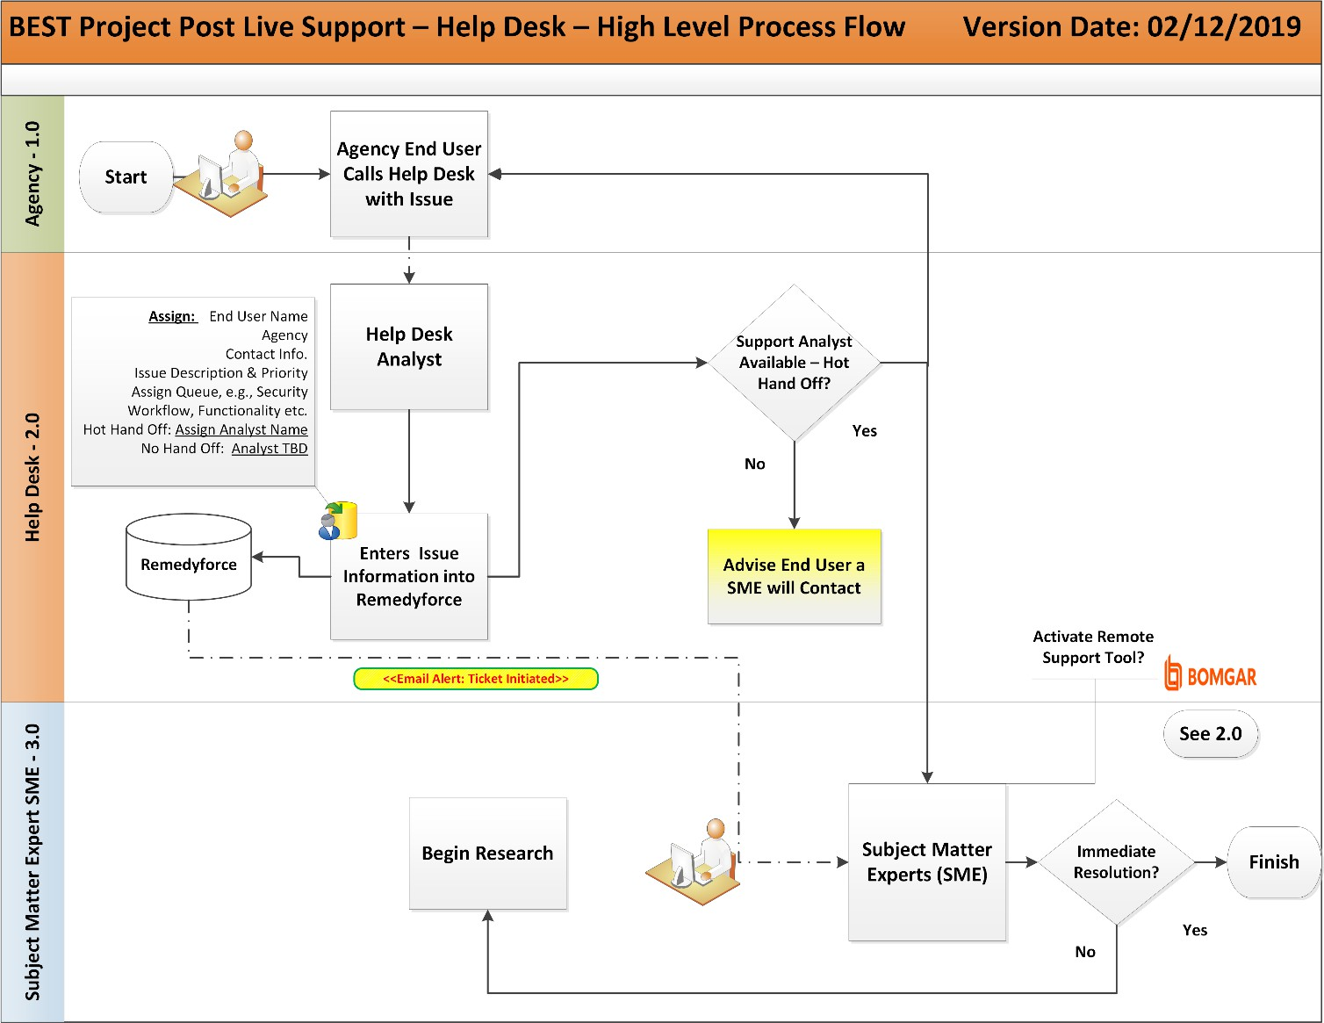

Description

Agency 1.0
  - The High Level Process Flow begins with an agency end user calling the BEST Project Help Desk phone number with an issue. The issues encountered by end users will vary and will be categorized into a “Major Issue Group” consisting of: 1) Security & Workflow, 2) Functionality, 3) Technical, 4) Training Need, and 5) Not Identifiable-Unknown. The issue is sub-categorized into more specific areas related to the application functionality.

Help Desk 2.0
  - The end-user’s call will be routed to a BEST Help Desk Analyst who will establish initial contact and record the issue and pertinent information into Remedyforce. After the information is collected, the Help Desk Analyst will attempt to assign the end-user’s issue immediately by phone to an appropriate Subject Matter Expert (SME) based on the major issue group; this is referred to as a hot handoff. Whether the issue is assigned to a SME via hot handoff or not, an email notification alert will be generated by Remedyforce advising the SME Major Issue Group’s resources, (e.g., all Security & Workflow SME resources), of the newly created Service Request (SR) issue.

Subject Matter Expert (SME) 3.0
  - This Subject Matter Expert (SME) will be deployed either through the hot handoff method, or the standard or non-hot handoff method. If an appropriate SME is not immediately available, the Help Desk Analyst will follow the standard method, and will advise the end user their issue will be resolved by a SME who will contact the end user within 24 hours. Again, if the appropriate SME is immediately available to speak with the end user, the issue is considered a hot handoff and the SME will begin immediately to identify a potential resolution. If there is no SME immediately available, the end user will be notified of the same and an appropriate SME will contact the end user within 24 hours to gather information and begin research to resolve the issue and close the ticket.
    - To facilitate end user issue resolution, the SME may advise the end user to initiate a remote support tool, BOMGAR, in order to view the end user’s application view. The detail process with descriptive content follow on the next page.

BOMGAR Detailed Process – Continuance

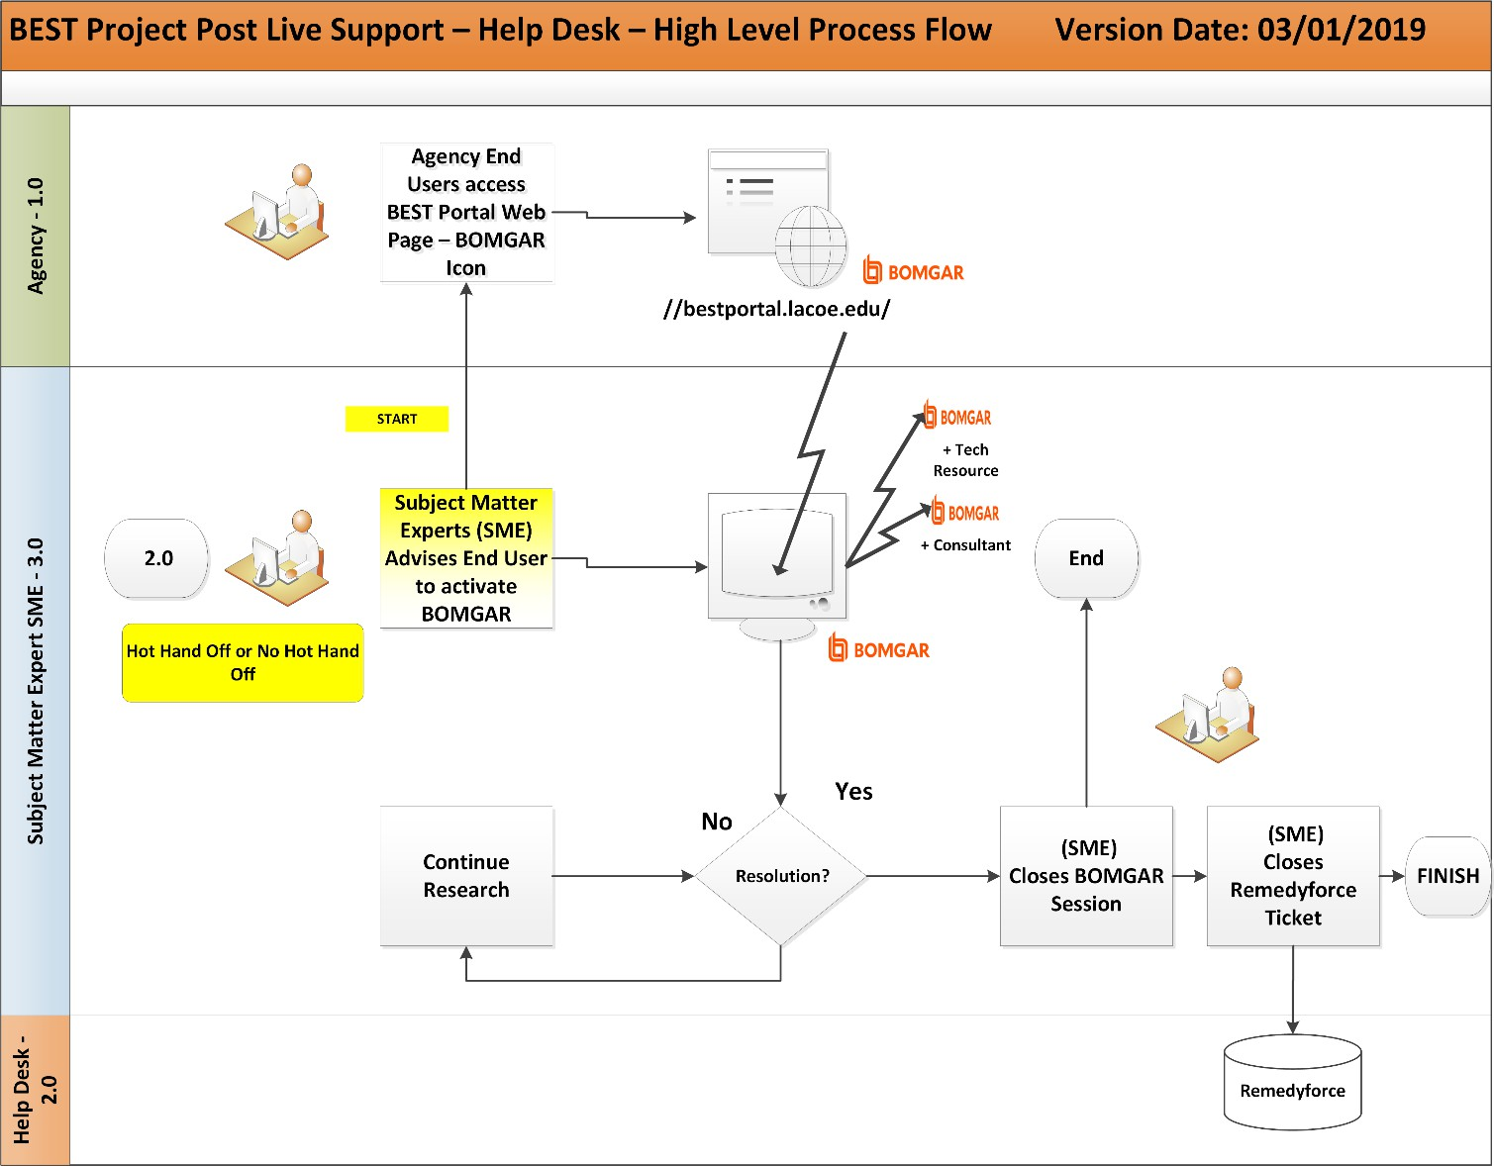

Description

Subject Matter Expert (SME)
  - The process flow (continuation) starts with the Subject Matter Expert (SME) determining a BOMGAR session is needed to diagnose the end user’s issue; note: the SME signs into BOMGAR in advance.

End User
  - As advised, the end user enters to the BEST Portal Webpage (URL) in their browser and selects the BOMGAR Client Support Icon on the Webpage to initiate the session; the end user then selects the name of the SME assisting them, which appears on the screen.

Subject Matter Expert (SME)
  - Once the session commences, the SME will advise the end user to release control of their screen if appropriate; alternatively, the SME may request the end user perform an example of the transaction which yields the end user’s issue described.
  - If a solution is immediately determined, the SME will close the BOMGAR session and then close the Remedyforce ticket.
  - If a solution is not immediately determined, the SME may end the session and perform additional research. Later when a solution is determined, the SME may re-initiate a BOMGAR session with the end user to demo the solution; thereafter, the SME closes the session and then closes the Remedyforce ticket.

Issue Resolution Detail Process

Purpose
The Issue Resolution Detail Process (No Hot Handoff) is intended to provide a more in-depth visual roadmap of the issue resolution process when a SME is not immediately available to speak with the end user when they phone the BEST Help Desk. The workflow begins when the Help Desk Analyst opens a ticket in Remedyforce and highlights the process a SME will follow through the conclusion when the ticket issue is resolved and the ticket is closed.
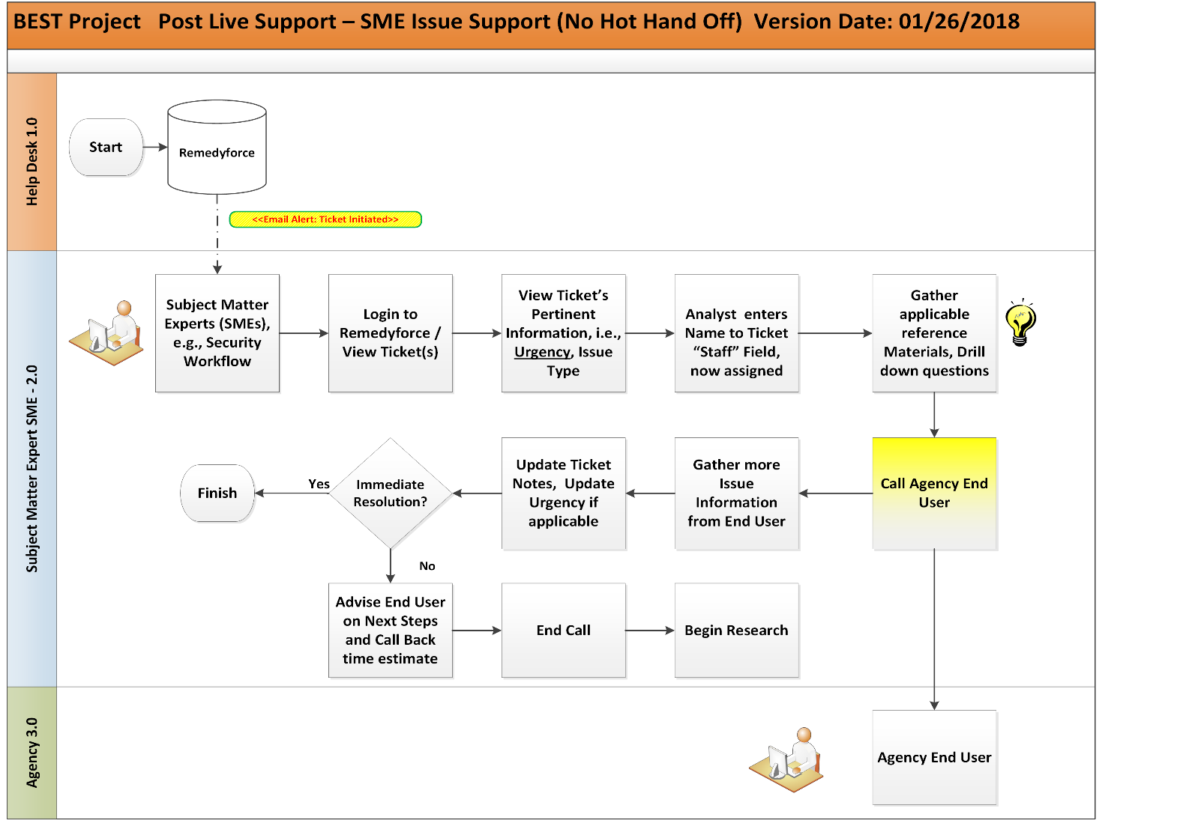

Description

Help Desk 1.0
  - The Subject Matter Expert Issue Support (No Hot Handoff) process begins when a Remedyforce ticket is created by a Help Desk Analyst who has captured the necessary details during their initial contact with an end user.

Subject Matter Expert (SME) 2.0
  - Once the ticket has been saved by the Help Desk Analyst, a system-generated email will be sent to the appropriate Subject Matter Experts based on the issue type, i.e., Major Issue Group Category, who will login to Remedyforce to view the ticket(s), applicable to their area of expertise. The SME will view the ticket’s initial pertinent information, which will provide

details including: end-user contact information, issue explanation, issue type, urgency^{i}, and more. Once the SME is ready to begin ticket resolutions, he or she will assign themselves as the owner by entering their name in the “Staff” Field of the Remedyforce ticket; the ticket is now officially an assigned ticket. The SME will then begin to gather applicable reference materials, and work through the process to resolve the ticket issue.
  - Specifically, the SME will contact the agency end user, making updates to the ticket notes simultaneously. If necessary, the SME may also update the ticket urgency type with the noted exclusionii. The SME will perform ongoing issue research and testing until the matter is resolved.
  - If a resolution is not found within the issue initial time estimation, the SME will advise the end user on next steps and provide an updated time-to-completion estimation. Once the ticket issue is resolved, the SME will notify the reporting end user and close the ticket.
    - Issues will have their urgency initially classified as “Normal Level” by the Help Desk Analyst, “Medium Level” may be used to assign a higher level of urgency by the SME.
    - If “High Level” and “Critical Level” urgency level are selected, upper-management staff will be notified; therefore, these Remedyforce urgency types should not be selected.

Agency 3.0
  - The agency end user will be contacted by the SME assigned to the ticket, who may request additional information, provide additional instructions, or update the end user on ticket resolution progress.

New User Mandatory Training Process and Security Access Assignment
New User Mandatory Training Process Purpose
The above referenced process flow is presented in two parts; the first being the New User Mandatory Training
Process and the second, New User Security Access Assignment, presented in the following sub-section. The New User Mandatory Training Process is intended to provide an in-depth visual roadmap of the new user request, subsequent assigning of training course process, and training course completion. The workflow begins when the Security Workflow Team receives a UDOC Form or a Security Access Form generated from the District’s Security Administrator (DSA) and continues through the assignment of training courses from the Learning Management System (LMS), which the new user will be required to complete in order to gain active production status.
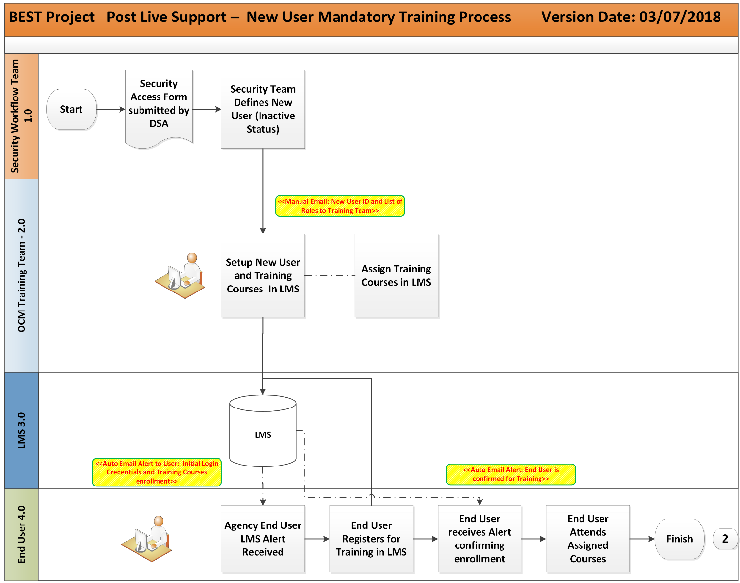

Description

Security Workflow Team 1.0
  - The New User Mandatory Training Process begins when the Security Workflow Team receives a UDOC Form (FIN or HCM) or a Security Request Form (BUD) from the DSA, which must include the end user’s Security Roles and Workflow Roles. The Security Workflow Team then ensures the new end user is defined in System Administration and sets the end user initially to inactive status. After the successful creation of the new end user, a manual email will be sent to the OCM Training Team with New User ID and their list of assigned security roles.

OCM Training Team 2.0
  - Upon receipt of the New User ID and assigned security roles, the OCM Training Team will setup the end user’s profiles and training courses required in the Learning Management System (LMS). Once the user is setup by the OCM Training Team, the new user will be assigned the mandatory training courses in LMS.

Learning Management System (LMS) 3.0
  - Once the new user is setup in LMS and the mandatory training courses are assigned, an auto system-generated email will be sent to the new user with LMS login credentials and mandatory training courses prompting the new user to login to LMS and register for training.

End User 4.0
  - When the new user receives the auto system-generated email alert, they will complete the provided setup instructions and register for mandatory training in LMS. A LMS generated auto- alert email will be sent to the end user confirming their training registration. The user will then attend the assigned training courses.

Security Access Assignment Process Purpose
The above referenced process flow, New User Security Access Assignment, is a continuance of the process flow
New User Mandatory Training Process, presented on the previous two pages. It is intended to provide an in- depth visual roadmap of what occurs after the agency end user completes assigned training courses, which is a prerequisite for the end user to activate access the production environment.
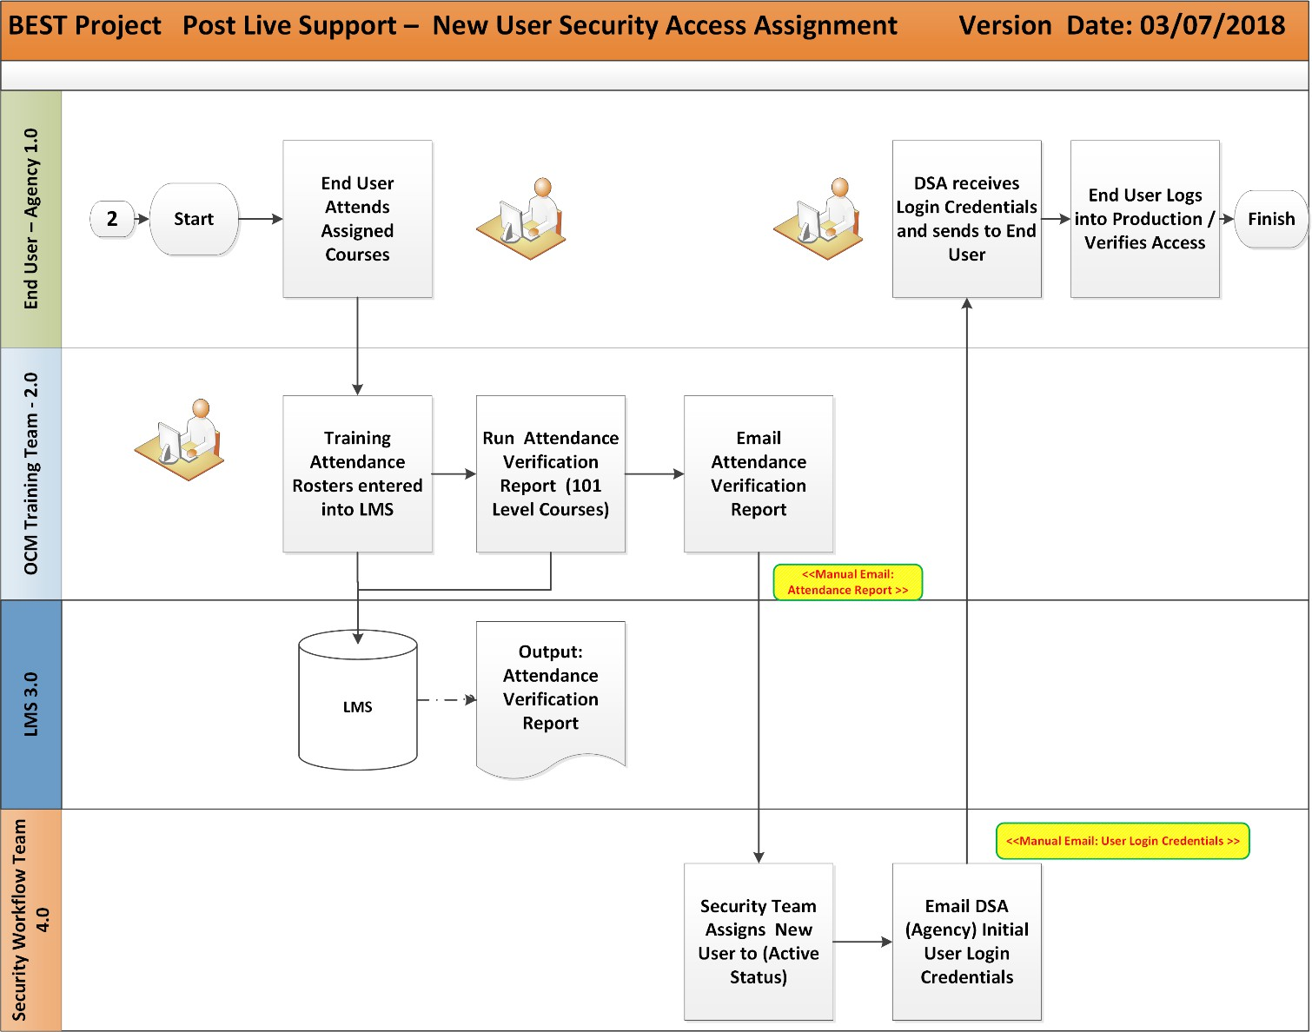
Description

End User / Agency:
  - The new end user attends the assigned training courses and records their attendance on the Training Attendance Roster presented by the Course Instructor. The end-user’s account status remains inactive at this juncture.

OCM Training Team 2.0
  - Upon receipt of the training course rosters, the OCM Training Team will manually enter completed training courses with training attendees into the Learning Management System (LMS). Thereafter, the Attendance Verification Report will be run in LMS and the output report will be emailed to the Security & Workflow Team to notify of resources that can be set to Active Status.

Learning Management System (LMS) 3.0
  - In this process flow lane, LMS is the system of record for training course(s) and training attendee assignments and subsequent completion.

Security & Workflow Team 4.0
  - The Security & Workflow Team receives the Attendance Verification Report (Level 101 Courses) from the OCM Training Team. Based on report, the Security & Workflow Team will assign the new end users to Active Status in the production environment. They will then email the District Security Administrator (DSA) the end-user login credentials.

End User / Agency 1.0
  - The DSA receives the new user login credentials and forwards the same to the end user (Now Active Status). The new end user then verifies access by logging into the production environment. If a log-in issue is encountered, the DSA or the end user will call the BEST Help Desk phone number to speak to a BEST Help Desk Analyst and initiate an issue to be opened in the Remedyforce, see page 5: Help Desk High Level Overview.

Functionality BUG Solution Process

Purpose
The Functionality BUG Solution Process is intended to provide an in-depth visual roadmap of the functionality bug resolution process, where the term “Functionality Bug’ is defined to include system bugs or defects that originate in system functionality, modifications, or any technical issue that prohibits the use of the new system as was intended by system requirements. The workflow begins when the Help Desk Analyst opens a ticket in Remedyforce, highlights the process a SME will follow when a Bug is determined, and the subsequent use of Remedyforce and JIRA systems until the bug is resolved and the ticket is closed.

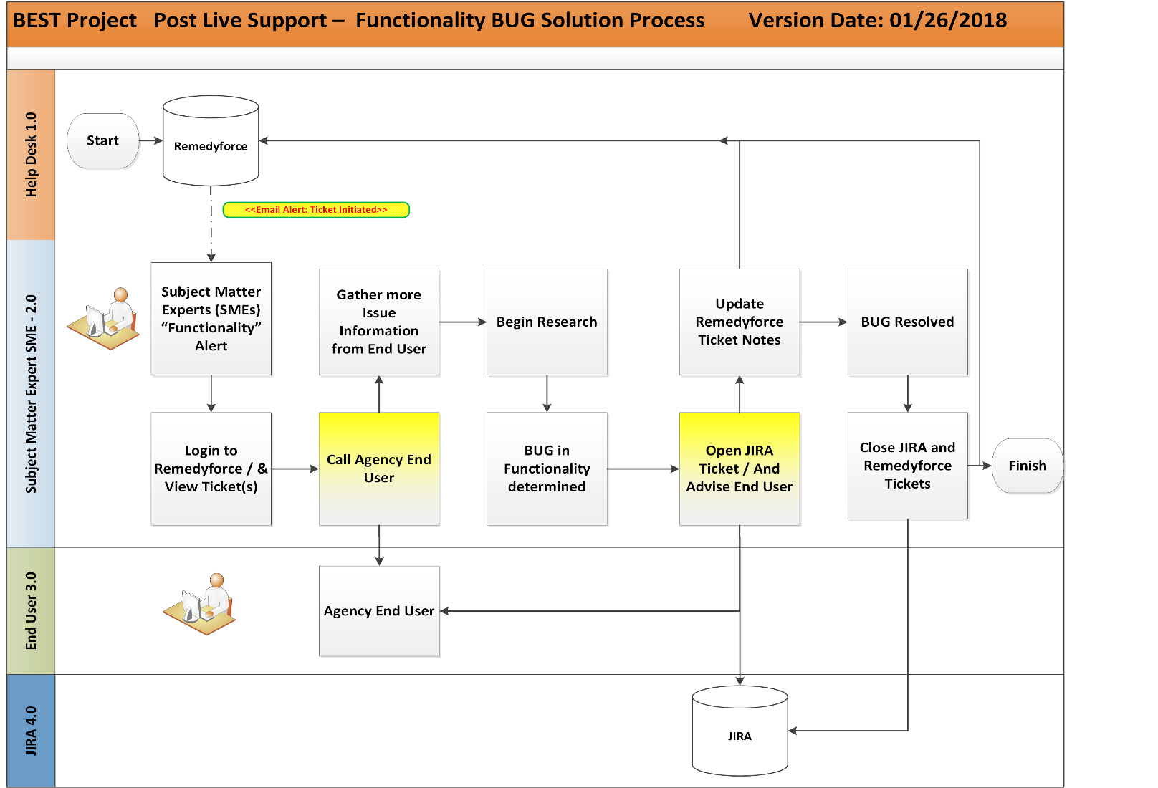

Description

Help Desk 1.0
  - The Functionality BUG Solution Process Workflow begins in Remedyforce when the issue ticket is created and an auto system-generated email alert is sent to the Subject Matter Expert (SME).

Subject Matter Expert (SME) 2.0
  - Once the Subject Matter Expert (SME) is alerted of the issue ticket in Remedyforce via a system-generated email, they will login and view the applicable ticket and the attached pertinent

information. The SME will call the agency end user who originally reported the issue and gather more information relating to the ticket.
  - After the SME obtains the necessary details, they will begin research, testing, and work through issue recreation steps to determine and verify the bug in functionality. Once the existence of a Functionality Bug is confirmed, the SME will open a ticket in JIRA and advise the agency end user on the reported issue status and confirming the existence of a Bug. The SME will further update the Remedyforce ticket confirming the existence of a Bug and will reference the JIRA ticket number in the originating Remedyforce ticket as well.
    - Note: It is possible for more than one Remedyforce ticket created for the same issue whose root cause is determined to be a Bug. If this occurs, the SME will determine the first and originating Remedyforce Ticket related to the Bug and this ticket will remain open. Any subsequent and additional tickets that exist will be closed by the SME and their respective end users informed of status. Only the originating Remedyforce Ticket will remain open until the Bug is resolved.
  - Upon accepted resolution of the Bug, the SME will be close both tickets in JIRA and Remedyforce, which will consequently complete the Functionality BUG Solution Process Workflow.

End User 3.0
  - The agency end user will be contacted by a SME throughout the Functionality Bug Solution Process Workflow to obtain further information regarding issue details, and to be updated on issue resolution status.

JIRA 4.0
  - Once the Functionality Bug has been confirmed, the SME will use JIRA as the primary issue tracking application for its resolution until the bug is closed.

Appendix A – BUD Post Go-Live Support Model


BUD WAVE 2 POST
LIVE Support Model -

Appendix B – FIN Post Go-Live Support Model / File

FIN WAVE 2 POST
LIVE Support Model -

Appendix C – HCM Post Go-Live Support Model / File

HCM Post Live Support Model Octob

